**How to do a Screenshot with Dual Screens**

Hold down both Screens CTRL and Print Screen at the same time

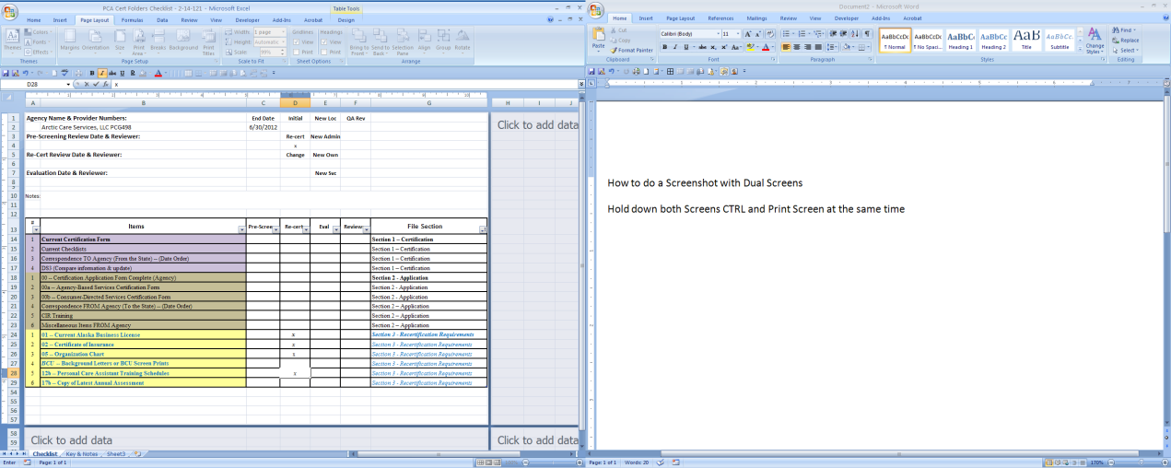

Paste into Word or Outlook E-mail using CTRL-V

Active Window ONLY

Hold down CTRL-ALT and Print Screen

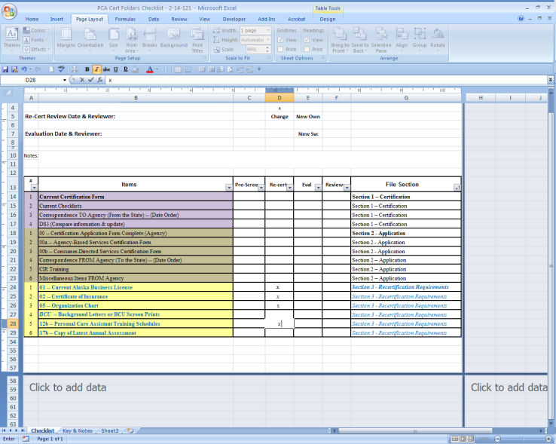

Paste into Word or Outlook E-mail using CTRL-V

**Editing or cropping pictures & screenshots**

Focusing on a ToolBar or smaller detail requires a little bit of editing both Word and Outlook can do this and do it the same way.

Click the picture to get the Handles around the outside.

Go to Picture Tools > Format

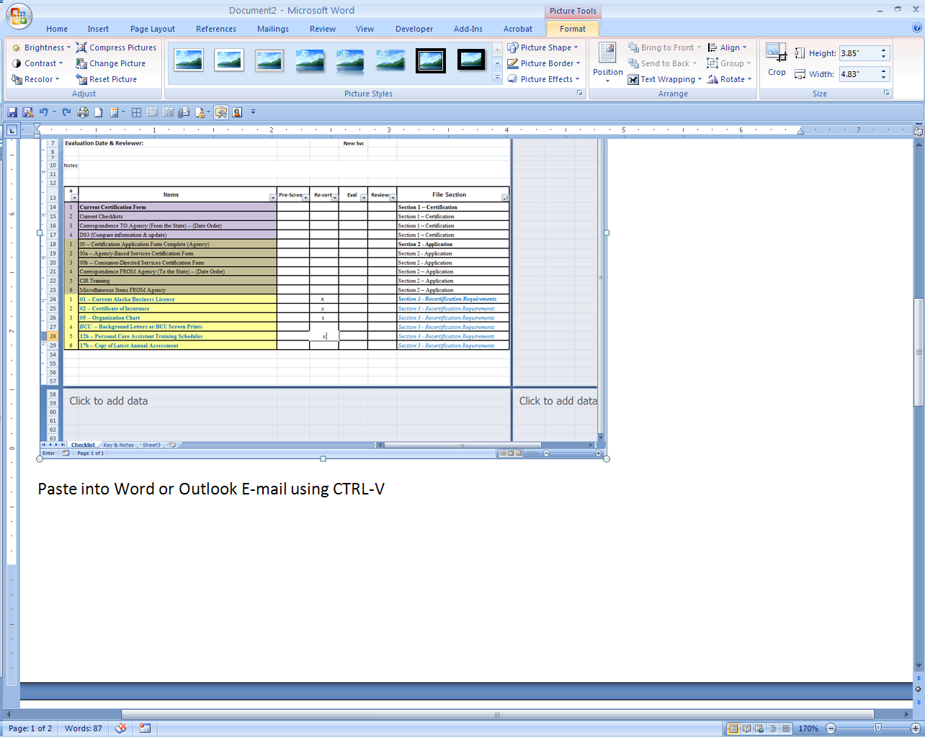



The Crop tool will allow you to cut the size of the picture down so you can focus on just what you need

To add Circles or Arrows with comments go to Insert > Shapes and pick what you need. 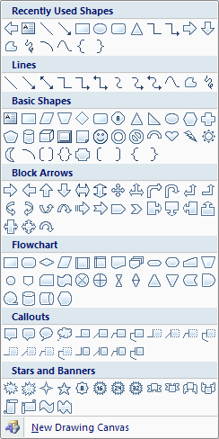

Change the color and size with the Drawing Tools or Text Box Tools Menus depending on the shape you used.

